**Project-2**

**USA Consumer Data Analysis**

1. Write a mapreduce program to remove commas present inside the double quotes.

Driver Class:

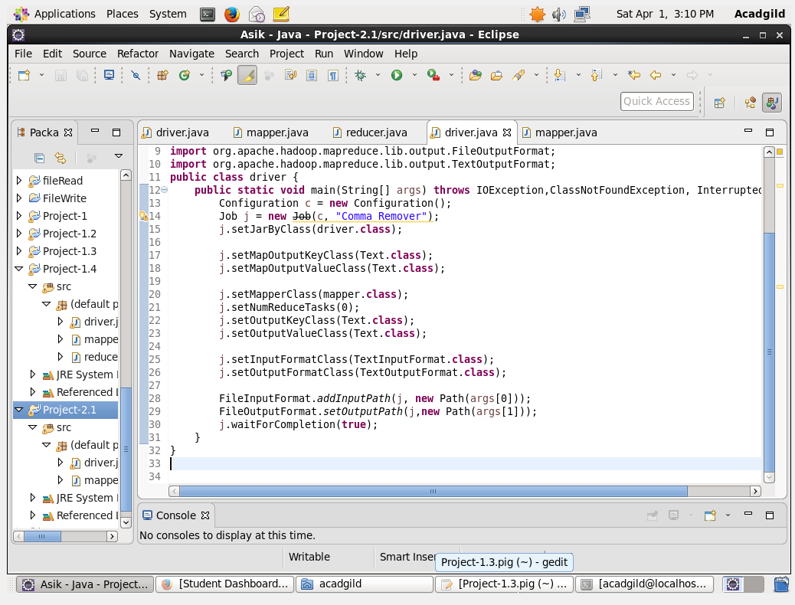

We are setting the job configurations in the driver class and we are using a map-only job. Therefore we are setting the Num reduce tasks to zero. The Output Format for key and values are set to Text Format.

Mapper Class:

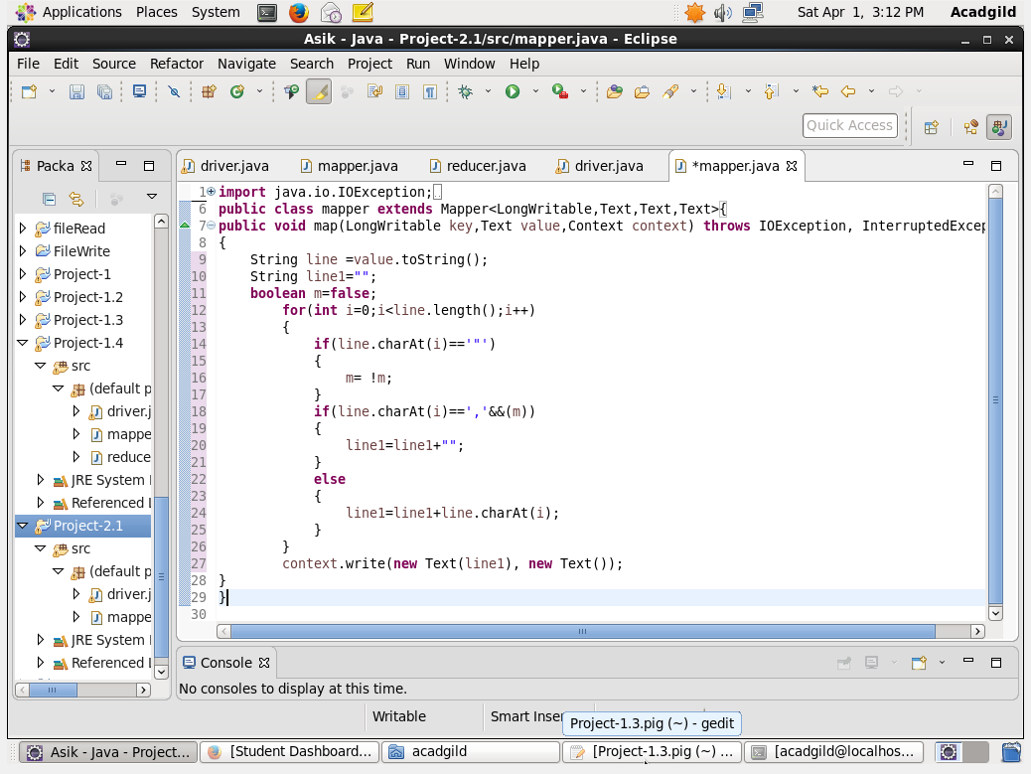

We are setting the boolean as false and it will reverses it state when there is a double quote.Andwhenever it encounters a comma and is within double quotes it removes the comma.

Input Text File:

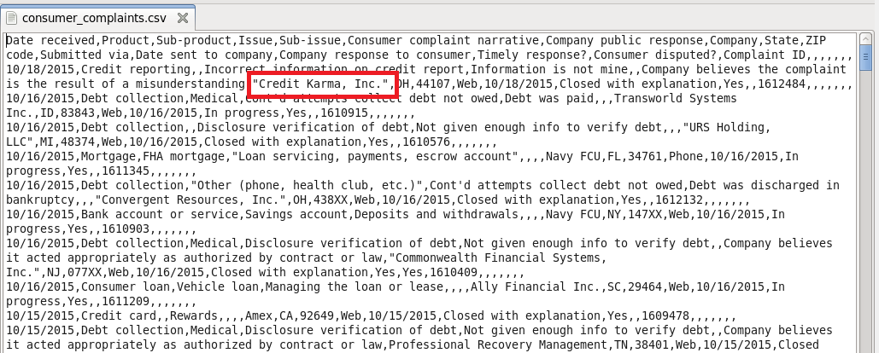

Output: We are running the jar file and in the output we can see that the comma is removed

